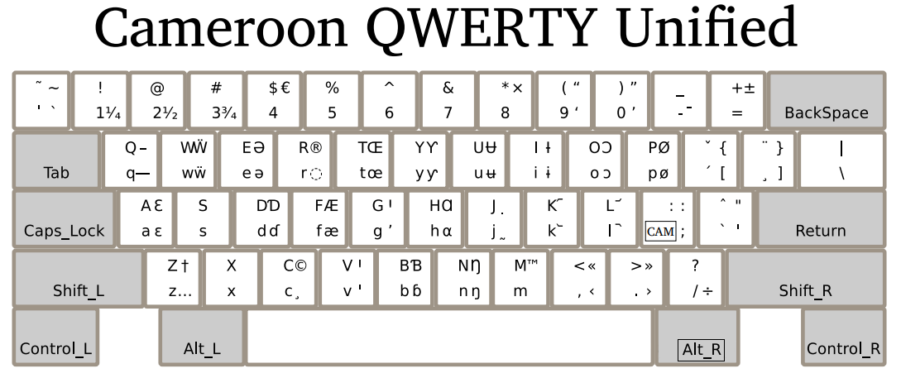**Practice:**

1. **Print out the full keyboard chart on page 1 and circle the letters used in your language. This will make it easier to find these important letters on your keyboard when you type.**
2. **Take some time to find and type each of the letters in your language. Write down any combinations that are hard to remember.**
3. **Now try typing tone or other diacritics of your language on the letters.**

**Using the Cameroon QWERTY Keyboard: Typing Letters**



**Each key on the Cameroon Keyboard can be used to produce multiple characters (letters).**

1. If you tap the  key once, you will get a lowercase "e".

**Sometimes you may need to use two keys to get the letter you want. The SHIFT key is a key on a computer keyboard. It is used to type capital letters (like this: "ABC") instead of lowercase ("abc").**

2. If you hold the key and tap the  key once, you will get a capital "E".

**The Cameroon Keyboard is special, and it is possible to type other Characters not printed on your keyboard using the "CAM" (Cameroon) key. On your Cameroon QWERTY Keyboard, the CAM key is the semicolon key (****). Each time you need the CAM key, just press** **.**

**To get the special characters shown on the right side of each key in the chart (like this: “əɔɓ”) instead of common characters (like “eob”), you need to use the CAM key.**

3. If you tap the  key once, and then press the  key, you will get schwa "ə".

**Sometimes you may need to use three keys to get the letter you want.**

4. If you tap the  key once, then hold and type , you will get capital schwa “Ə”.

**In review, if you look at the keyboard chart, you’ll see that most keys on the Cameroon keyboard can be used to produce up to four different characters in this way. Use the chart to find the letters you need for your language, and use a combination of and the CAM Key (****) to type them.**

|  |  |  |
| --- | --- | --- |
| Example |  | **Combinations:**   = b   +  = B   then  = ɓ   then +  = Ɓ |

*Note: Advanced users may be interested to know that you can hold the Right Alt key, known as ALT GR instead of tapping the CAM (semicolon) key.*

**Using the Cameroon Keyboard: Tones, Diacritics and other Characters**

While diacritics such as tones may be harder to see on the chart, they are typed in the same way as other letters. **Note: Unlike French, diacritics on the Cameroon keyboard must be typed AFTER the letter.**

|  |  |  |
| --- | --- | --- |
| Example |  | Combinations:   = ˊ (High Tone)  +  = ˇ (Rising Tone)   then  = [   then +  = { |

Look carefully at the key image above taken from the keyboard chart.

-To type an “a” with a high tone (á), you must type  then .

-To type an “A” with a rising tone (Ǎ), you must hold and type  then hold and type .

Some uncommon characters have been hidden to make way for more common Cameroon characters.

-To type “[”, you must tap  and then type .

-To type “{”, you must tap  and then hold and type .

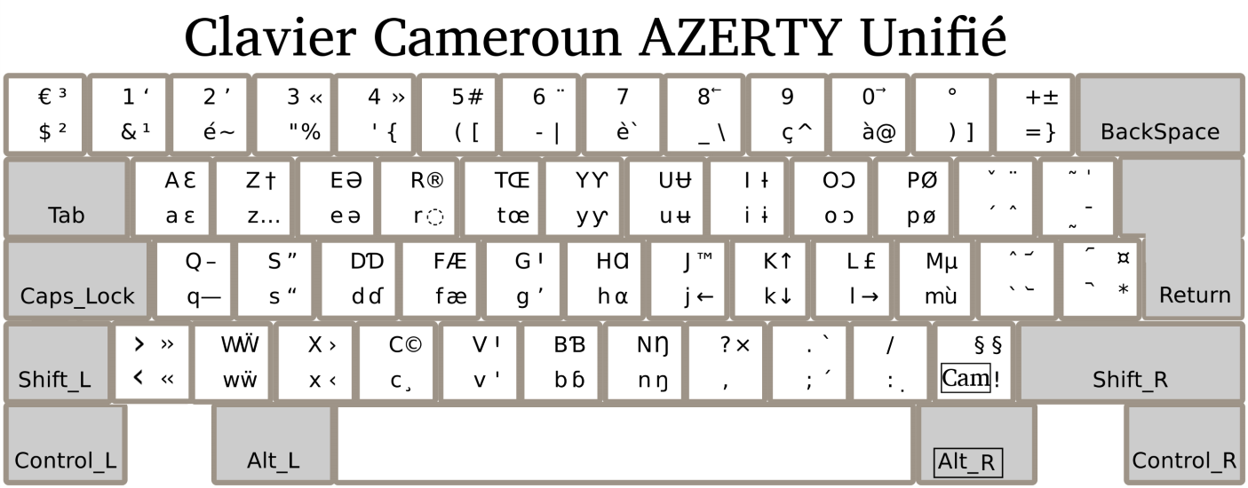

**Practice:**

1. **Print out the full keyboard chart on page 1 and circle the letters used in your language. This will make it easier to find these important letters on your keyboard when you type.**
2. **Take some time to find and type each of the letters in your language. Write down any combinations that are hard to remember.**
3. **Now try typing tone or other diacritics of your language on the letters.**

**Using the Cameroon AZERTY Keyboard: Typing Letters**



**Each key on the Cameroon Keyboard can be used to produce multiple characters (letters).**

1. If you tap the  key once, you will get a lowercase "e".

**Sometimes you may need to use two keys to get the letter you want. The SHIFT key is a key on a computer keyboard. It is used to type capital letters (like this: "ABC") instead of lowercase ("abc").**

2. If you hold the key and tap the  key once, you will get a capital "E".

**The Cameroon Keyboard is special, and it is possible to type other Characters not printed on your keyboard using the "CAM" (Cameroon) key. On your Cameroon AZERTY Keyboard, the CAM key is the exclamation key (). Each time you need the CAM key, just press .**

**To get the special characters shown on the right side of each key in the chart (like this: “əɔɓ”) instead of common characters (like “eob”), you need to use the CAM key.**

3. If you tap the  key once, and then press the  key, you will get schwa "ə".

**Sometimes you may need to use three keys to get the letter you want.**

4. If you tap the  key once, then hold and type , you will get capital schwa “Ə”.

**In review, if you look at the keyboard chart, you’ll see that most keys on the Cameroon keyboard can be used to produce up to four different characters in this way. Use the chart to find the letters you need for your language, and use a combination of and the CAM Key (****) to type them.**

|  |  |  |
| --- | --- | --- |
| Example |  | **Combinations:**   = b  +  = B  then  = ɓ  then +  = Ɓ |

*Note: Advanced users may be interested to know that you can hold the Right Alt key, known as ALT GR instead of tapping the CAM (semicolon) key.*

**Using the Cameroon Keyboard: Tones, Diacritics and other Characters**

While diacritics such as tones may be harder to see on the chart, they are typed in the same way as other letters. **Note: Unlike French, diacritics on the Cameroon keyboard must be typed AFTER the letter.**

|  |  |  |
| --- | --- | --- |
| Example |  | Combinations:   = ˊ (High Tone)  +  = ˇ (Rising Tone)  then  = [  then +  = { |

Look carefully at the key image above taken from the keyboard chart.

-To type an “a” with a high tone (á), you must type  then .

-To type an “A” with a rising tone (Ǎ), you must hold and type  then hold and type .

Some uncommon characters have been hidden to make way for more common Cameroon characters.

-To type “[”, you must tap  and then type .

-To type “{”, you must tap  and then hold and type .